### **LAB-4**

### LAB 4-1

### A. Simple Proactive Hub Application

Testing:

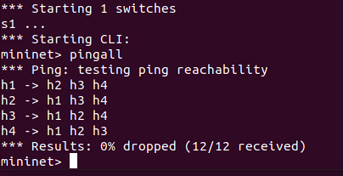



### B. Simple Switch Application (in built)

Testing:

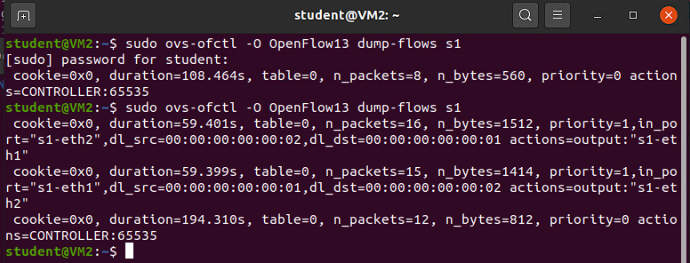

### C. Simple Switch with L3 Match Application

Testing -

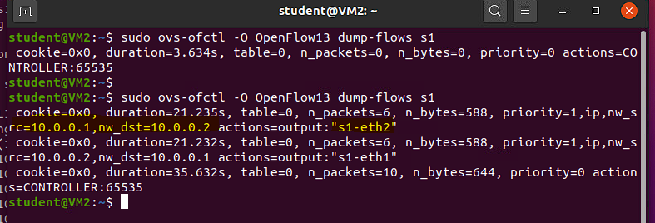

### D. Simple Switch with L4 Match Application

Testing -

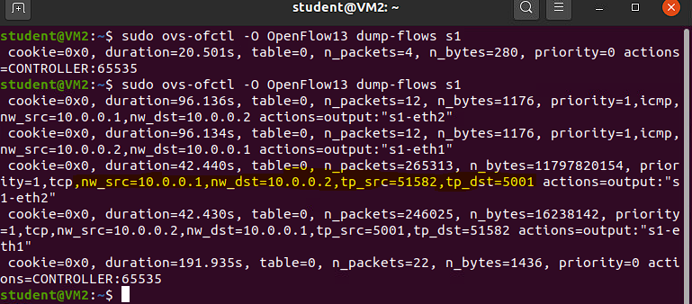

### E. Simple Switch with flow expiry (flow timeouts configured)

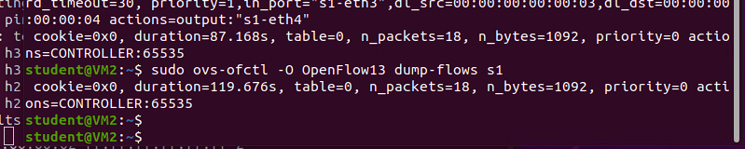

### LAB 4-2:

**Get Statistics-**

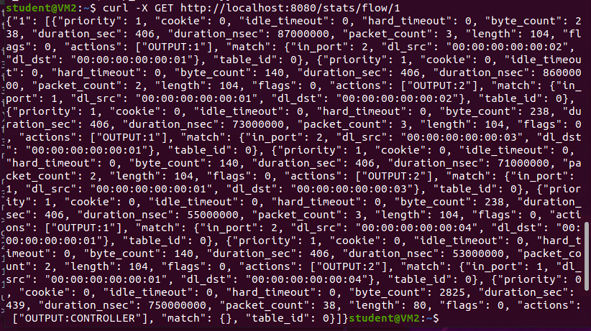

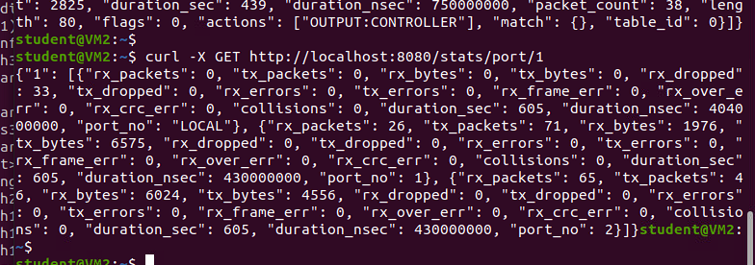

**Continue to next page**

**Example – Hub**

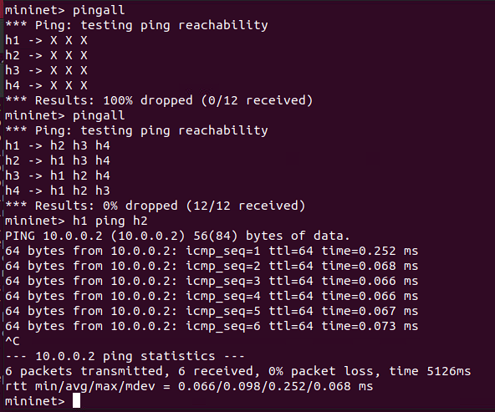

**Example – Switch**

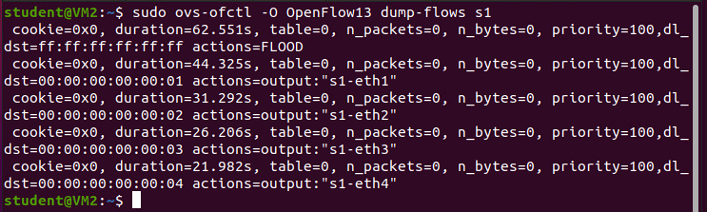

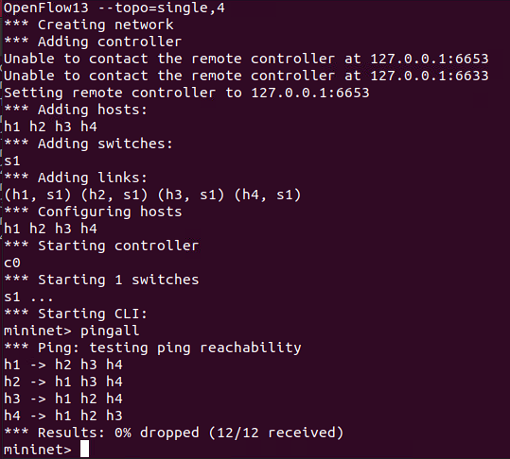

**Example – Multitable**

